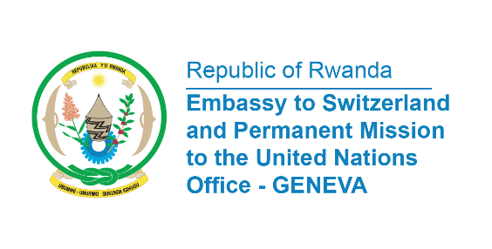

38th Session of the Universal Periodic Review Working Group
Review of Paraguay
5th May 2021
Statement delivered by Ms. Marie Chantal Rwakazina, Ambassador and Permanent Representative

Rwanda warmly welcomes the delegation of Paraguay to the UPR working Group and thank them for the presentation of their National Report.
We commend Paraguay for the progress made in implementing the recommendations it received in the previous review. In particular, we take positive note of the adoption of National Education Plan 2024 containing actions to improve access to and the quality of education.
We also take note of the adoption of Act No. 5777/16 on the Comprehensive Protection of Women from All Forms of Violence.

Rwanda would like to recommend the following:
- Ratify the Convention against Discrimination in Education;
- Step up efforts to prevent, combat and punish femicides and all acts of violence against women, girls and adolescents as recommended by The Human Rights Committee;
- Continue efforts to improve detention conditions including reducing overcrowding.

We wish Paraguay a successful review.
Thank you.

