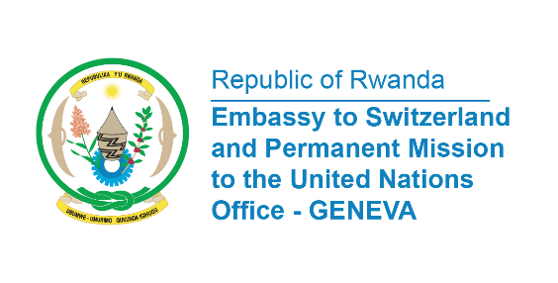

38th Session of the Universal Periodic Review Working Group
Review of Namibia
3rd May 2021
Statement delivered by Mrs. Marie Chantal Rwakazina, Ambassador and Permanent Representative

Thank you, Madam President,
My delegation welcomes the delegation of Namibia headed by Honourable Ms. Yvonne Dausab, Minister of Justice and thanks them for the Presentation of their National Report on human rights Situation in the Country and the engagement with the UPR Process.
We take positive note of the progress made by Namibia in promotion and protection of human rights in the country. In particular, Rwanda welcomes the establishment in 2020 of the Ministry of Gender Equality, Poverty Eradication and Social Welfare.
In constructive spirit, Rwanda recommends Namibia the following:
- Ratify the International Convention on the Protection of the Rights of All Migrant Workers and Members of Their Families;
- Take effective measures in rural areas to reduce the distance from households to water points.

We wish Namibia a success review

I thank you

