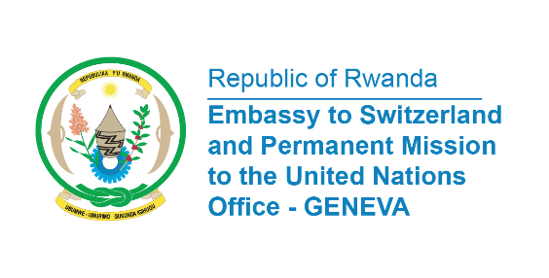

38th Session of the Universal Periodic Review Working Group
Review of Mozambique
4th May 2021
Statement delivered by Mr. Jean de Dieu BUDUREGE, Communications and Multilateral Officer.

Thank you, Madam President,
Rwanda extends a warm welcome to the delegation of Mozambique and thanks them for the Presentation of their National Report.
We commend Mozambique for the progress made in promoting and protecting human rights of its people since the 2nd UPR Cycle.
In particular, we acknowledge the adoption of severe measures to combat violence against children, through the application of criminal sanctions.
Rwanda also commends Mozambique for enacting law No. 10/2017, which aligned paid maternity leave benefits with international standards.

In a constructive spirit, Rwanda recommends Mozambique the following:
- Consider ratify the International Covenant on Economic, Social and Cultural Rights;
- Ratify the UNESCO Convention against Discrimination in Education.
We wish Mozambique a successful review.

I thank you.

