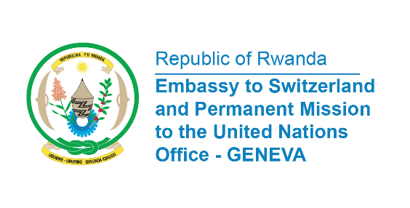

38th Session of the Universal Periodic Review Working Group
Review of Latvia
11th May 2021
Statement delivered by Mr. Jean de Dieu BUDUREGE, Communications and Multilateral Officer

Madame President,
We would like to extend a warm welcome to the delegation of Latvia and thank them for their comprehensive National Report.
Rwanda welcomes the progress of the involvement of women in Latvia’s political processes. In particular, we take positive note that in 2018 parliamentary election, 31 women were elected, which is an increase of 12 more women compared to the 2014 elections.
In a constructive spirit, Rwanda would like to make the following Recommendations for Latvia’s consideration:
- Review the adequacy of its legislation in addressing and sanctioning racist hate speech and incitement to racial hatred.
- Adopt a comprehensive strategy to combat discriminatory stereotypes regarding the roles and responsibilities of women and men in the family and in society.
- Adopt a comprehensive law on gender-based violence against women

We wish Latvia a successful review

I thank you.

