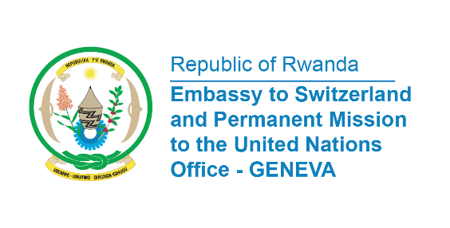

38th Session of the Universal Periodic Review Working Group
Review of Estonia
4th May 2021
Statement delivered by Mrs. Marie Chantal Rwakazina, Ambassador and Permanent Representative

Thank you, Madam President,

My delegation welcomes the delegation of Estonia and thanks them for the update on human rights situation in the country.
Rwanda commends Estonia for establishing a national institution for the promotion and protection of human rights whose functions were assigned to the Chancellor of Justice in compliance with the Paris Principles.
We take positive note of the approval in 2016, of the “Welfare Development Plan for 2016–2023”, which aims to reduce social inequality and poverty, promote gender equality and increase social inclusion.

Rwanda recommends the following:
- Ratify the UNESCO Convention against Discrimination in Education.
- Ratify the Optional Protocol to the Convention on the Elimination of All Forms of Discrimination against Women.
- Ratify the International Convention on the Protection of the Rights of All Migrant Workers and Members of Their Families
We wish Estonia a successful UPR.

I thank you

