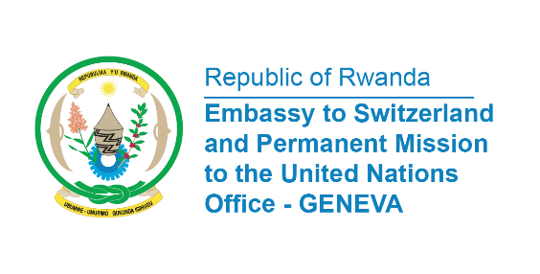

38th Session of the Universal Periodic Review Working Group
Review of Denmark
6th May 2021
Statement delivered by Mr. Jean de Dieu Budurege, Communications and Multilateral Officer

Rwanda warmly welcomes the delegation of Denmark and thanks them for the presentation of their National Report.
We commend Denmark for its active participation in the UPR mechanism and the progress made in implementation of the previous recommendations. In particular we take positive note that all residents in Denmark have access to public healthcare services.
We also appreciate the establishment in 2017 of a national unit for the prevention of domestic violence.
We would like to make the Following recommendations:
- Ratify the International Convention on the Protection of the Rights of All Migrant Workers and Members of Their Families;
- Develop and implement a national action plan to combat homelessness and provide long-term solutions and support social reintegration of homeless people;
- Expedite the establishment of a human rights institution in the Faroe Islands, in compliance with Paris principles.

My delegation wishes Denmark a successful review.

I thank you Madam President.

