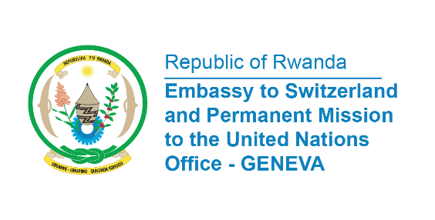

38th Session of the Universal Periodic Review Working Group
Review of Belgium
5th May 2021
Statement delivered by Ms. Marie Chantal Rwakazina, Ambassador and Permanent Representative

Thank you, Madam President,
We welcome the delegation of Belgium and thank them for thepresentation of their National Report and the engagement in the UPR process.
Rwanda recommends Belgium the following:
- To ratify the International Convention on the Protection of the Rights of All Migrant Workers and Members of Their Families;
- To adopt a national strategy for the inclusion of people of African descent in Belgium including migrants;
- To establish a national human rights institution in compliance with the Paris Principles;
- To ratify the Convention against Discrimination in Education.

My delegation wishes Belgium a successful review.

I thank you Madam President.

