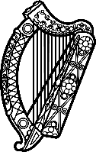

Statement of Ireland
38th session of the UPR Working Group

Review of Niger

3 May 2021

Ireland welcomes the delegation of Niger and thanks it for its presentation.
Ireland acknowledges Niger’s efforts to advance human rights domestically and progress made since the last UPR, particularly the work of Niger’s National Human Rights Commission.
Ireland is concerned at the situation of human rights defenders and journalists and encourages the protection of civil society space in Niger.
Ireland also remains concerned at the high rates of child marriage in Niger, and the persistence of harmful practices including female genital mutilation.
Ireland makes the following recommendations to the authorities of Niger:

- Accelerate the adoption of the bill on the protection of human rights defenders;
- Combat harmful practices against women and girls including female genital mutilation and child, early and forced marriage.

We wish Niger every success with this UPR cycle.

