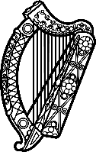

Statement of Ireland
38th session of the UPR Working Group

Review of Somalia

6 May 2021

Ireland thanks the delegation of Somalia for its presentation.

We acknowledge progress made since the last UPR, including ratification of international instruments, addressing the rights of persons with disabilities, and adoption of the National Reconciliation Framework.

Against the backdrop of an increasingly unstable political, humanitarian and security situation, Ireland is particularly concerned about the maintenance of civic and political space, the rights of marginalised and displaced communities, and the protection of women and girls.

Ireland makes the following recommendations:
- Adopt survivor-centred legislation on the prevention and prosecution of sexual offences, in conformity with international standards, and drawing on the text of the Sexual Offences Bill 2018.
- Review and reform provisions of relevant legislation, including the new media law introduced in August 2020, which impede freedom of expression and of the media, and align them with international standards.

We wish Somalia every success with this UPR cycle.

Thank you.

