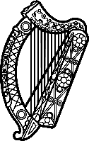

Statement of Ireland
38th session of the UPR Working Group

Review of Sierra Leone

12 May 2021

Ireland warmly welcomes the delegation of Sierra Leone and thanks it for its presentation today.
Ireland acknowledges Sierra Leone’s efforts to advance human rights domestically and commends the progress made.
We particularly welcome progress on Ireland’s previous recommendations, namely to repeal the criminal libel provisions of the Public Order Act and the lifting of the ban on pregnant girls attending school.
Ireland makes the following recommendations to the Sierra Leone authorities:
- Implement the recently launched Gender Equality and Women’s Empowerment Policy in its entirety;
- Address gender-based violence against women and girls, including through the approval of the National Strategy for the Reduction of Female Genital Mutilation/Cutting.
- Enact legislation as soon as possible to abolish the death penalty.
We wish Sierra Leone every success with this UPR cycle.
Thank you.

