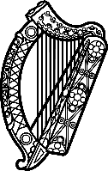

Statement of Ireland
38th session of the UPR Working Group

Review of Namibia

3 May 2021

Ireland welcomes the delegation of Namibia and thanks it for its presentation today.
Ireland acknowledges Namibia’s efforts to advance human rights domestically and welcomes progress made since the last UPR cycle.
We commend Namibia for establishing a Children’s Advocate in the Office of the Ombudsman, in line with recommendations from the last UPR. Ireland further commends Namibia for adopting a Child Care and Protection Act.
Ireland makes the following recommendations to the Namibian authorities:
- Ensure national policies to reduce gender-based violence and to protect women and girl’s rights are effectively implemented including through the provision of sufficient resources to support victims.
- Decriminalise consensual same-sex relations.
- Enshrine in legislation the prohibition of discrimination on the ground of sexual orientation and gender identity.

We wish Namibia success with this UPR cycle.
Thank you.

