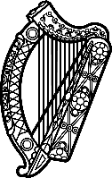

Statement of Ireland
38th session of the UPR Working Group

Review of Mozambique

3 May 2021

Ireland warmly welcomes the delegation of Mozambique and thanks it for its presentation.
Ireland acknowledges Mozambique’s efforts to advance human rights domestically and commends progress made since the last UPR cycle.
Ireland is concerned by reports of human rights violations being committed with impunity and by the shrinking of democratic and civic space in Mozambique.
Ireland makes the following recommendations to the Mozambican authorities:

- Ensure the prompt, thorough and impartial investigation of alleged human rights violations and abuses, and violations of International Humanitarian Law by all actors, including the security forces, and ensure that perpetrators are brought to justice.
- Take all necessary measures to fully protect the rights of freedom of expression, access to information, and media freedom for all, including human rights defenders, journalists and media workers.

We wish Mozambique every success with this UPR cycle.

Thank you.

