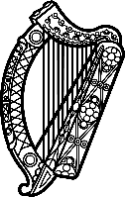

Statement of Ireland
38th session of the UPR Working Group

Review of Estonia

4 May 2021

Ireland warmly welcomes the delegation of Estonia and thanks it for its presentation today.

Ireland acknowledges Estonia’s efforts to advance human rights domestically and commends progress made since the last UPR cycle including the designation of the Chancellor of Justice as the national human rights institution, in line with the Paris Principles. We also welcome the efforts made nationally to address the gender pay gap.

Ireland makes the following recommendations to the Estonian authorities:

- Fully implement the Registered Partnership Act; through the implementation of provisions regarding cohabitation laws, in order to fully recognise the rights of same-sex families.

- Accelerate the acquisition of Estonian citizenship by removing remaining obstacles, such as incorporating a legal definition of a stateless person into domestic law.

Finally, we wish Estonia every success with this UPR cycle

Thank you.

