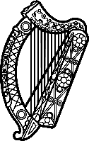

Statement of Ireland
38th session of the UPR Working Group

Review of Belgium

5 May 2021

Ireland welcomes the delegation of Belgium. Ireland acknowledges Belgium’s efforts to advance human rights domestically and commends progress made since the last UPR.

We commend Belgium’s leadership role on the abolition of the death penalty. We welcome the Act creating the Federal Institute for the Protection and Promotion of Human Rights.

Ireland is concerned about the detention of migrant children, including the detention of families with children for deportation purposes.

Ireland makes the following recommendations to the Belgian authorities:
- Expedite the establishment of the Federal Institute for the Protection and Promotion of Human Rights, in compliance with the Paris Principles.
- Strengthen efforts to protect the rights of migrant children, in line with recommendations made by the Committee on the Rights of the Child.

We wish Belgium every success with this UPR cycle.
Thank you.

