Jamhuuriyadda Federaalka Soomaaliya  Ergada Joogtada Soomaliyeed ee Qaramada Midoobey ee Geneva | 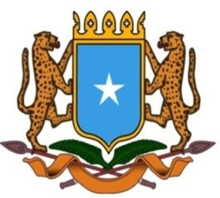 | جمهورية الصوما ل الفيدرالية  البعثة الدائمة لجمهورية الصومال بمكتب الأمم المتحدة بجنيف وبالوكالات المتخصصة بسويسرا

Permanent Mission of the Federal Republic of Somalia to the United Nations Office at Geneva and other International Organizations in Switzerland

Check Against Delivery
Statement by the Delegations of Somalia,
Mr. Abdulkadir Hussein, First Secretary
At the Review of the Kingdom of Denmark, during the 38th Session of the UPR Working Group on Thursday, 06 May, 2021 from 9:00AM to 12:30PM, in the Assemble Hall of the Palais des Nations in Geneva, Speaker Number 87, Time: 1 minute 05 second.

Thank you Chair,

Somalia welcomes the delegation of the Kingdom of Denmark to this session of the UPR Working Group and commends for their commitment to the UPR process.

We welcome the initiatives undertaken to improve integration of non-citizens and minorities into Danish society. However, Somalia notes with regret the significant increase in the number of children with ethnic background living in poverty, as well as the high incidence of sexual violence.

In this regards Somalia recommends the following:

- To further strengthen its commitment to protect women from violence and discrimination, including through effective measures for its prevention, investigation, prosecution, and conviction of the perpetrators of such abuses

- To take all appropriate measures in order to ensure equality in all aspect of life for the children living in the country regardless of their religion or national origin,

In conclusion, We wish the delegation of Denmark a successful review.

I thank you Chair.

