Jamhuuriyadda Federaalka Soomaaliya  Ergada Joogtada Soomaliyeed ee Qaramada Midoobey ee Geneva | 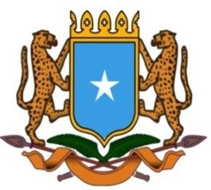 | جمهورية الصوما ل الفيدرالية  البعثة الدائمة لجمهورية الصومال بمكتب الأمم المتحدة بجنيف وبالوكالات المتخصصة بسويسرا

Permanent Mission of the Federal Republic of Somalia to the United Nations Office at Geneva and other International Organizations in Switzerland

Check Against Delivery
Statement by the Delegations of Somalia,
Mr. Hussen Abdi Musa, First Counsellor
at the Review of the Kingdom of Belgium, during the 38th Session of the UPR Working Group on Wednesday, 05 May, 2021 from 9:00AM to 12:30PM, in the Assemble Hall of the Palais des Nations in Geneva, Speaker Number 87, Time: 055 second.

Thank you Chair,

Somalia welcomes the delegation of the Kingdom of Belgium to this session and thanks it for the presentation of its national report.

We acknowledge the efforts made by the government to fulfill its human rights obligations through the implementation of the accepted recommendations and ratification of several human rights instruments, however We recommend the following for consideration :

- To Consider ratifying the International Convention on the Protection of the Rights of All Migrant Workers and Members of Their Families (CRMW).

- To take all the necessary measures to facilitate administrative proceeding related to family reunification for beneficiaries of international protection, including by reducing the processing time for the visa application and also by exempting the condition related to the economic status of the applicant, such as regular and sufficient means of subsistence, adequate housing and health insurance coverage.

To conclude, We wish the delegation of Kingdom of Belgium a successful review.

I thank you Chair.

