Jamhuuriyadda Federaalka Soomaaliya  Ergada Joogtada Soomaliyeed ee Qaramada Midoobey ee Geneva | 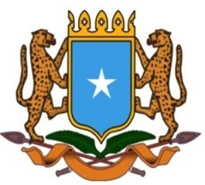 | جمهورية الصوما ل الفيدرالية  البعثة الدائمة لجمهورية الصومال بمكتب الأمم المتحدة بجنيف وبالوكالات المتخصصة بسويسرا

Permanent Mission of the Federal Republic of Somalia to the United Nations Office at Geneva and other International Organizations in Switzerland

Check Against Delivery
Statement by the Delegations of Somalia,
Mr. Hussen Abdi Musa, First Counsellor
at the Review of the Republic of Namibia, during the 38th Session of the UPR Working Group on Monday, 03 May, 2021 from 9:00AM to 12:30PM, in the Assemble Hall of the Palais des Nations in Geneva, Speaker Number 3, Time: 1 minute.
Thank you Chair,

Somalia would like to warmly welcome the esteemed delegation of Namibia to its third cycle of the UPR and congralutes the excellent presentation of its national report.

We commend the increased efforts made by the government of Namibia in strenghtening its legal and institutional framework and also in implementing the recomendations received since last review.

We therefore encourage the government of Namibia to continue its endeavor aimed at promoting and protecting human rights and call upon the international community to provide the assistance requested by Namibia in its national report.

In a constructive spirit, we recommend to Namibia :
- To consider ratifying the International Convention on the Protection of the Rights of All Migrant Workers and Members of Their Families (CRMW),

- To continue upholding the capacities of the government officials and citizens on the principles of human rights values through education and training programmes.
To conclude, We wish Namibia a very successful review. I thank you Chair.

