Jamhuuriyadda Federaalka Soomaaliya  Ergada Joogtada Soomaliyeed ee Qaramada Midoobey ee Geneva | 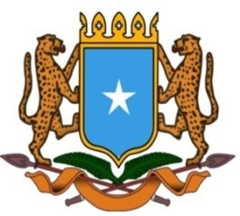 | جمهورية الصوما ل الفيدرالية  البعثة الدائمة لجمهورية الصومال بمكتب الأمم المتحدة بجنيف وبالوكالات المتخصصة بسويسرا

Permanent Mission of the Federal Republic of Somalia to the United Nations Office at Geneva and other International Organizations in Switzerland

Check Against Delivery
Statement by the Delegations of Somalia,
Mr. Hussen Abdi Musa, First Counsellor
at the Review of the Republic of Mozambique, during the 38th Session of the UPR Working Group on Tuesday, 04 May, 2021 from 9:00AM to 12:30PM, in the Assemble Hall of the Palais des Nations in Geneva, Speaker Number 101, Time: 1 minute.

Thank you Chair,

Somalia welcomes the distinguished delegation of Mozambique to this UPR Working Group and congratules the presentation of its national report.

We appreciate the political will of the government in addressing key human rights situations and also the progress made in implementing the recommendations accepted during the previous reviews.

We welcome measures taken by the government to combat corruption and inequalities among citizens in all spheres of life, including public life and education. In this regard, we wish to congratulate the government the growth of women’s representation in government institutions at all level.

In the spirit of constructive diologue, we recommend to Mozambique the following for consideration :

- To accelerate the implementation process of the Master plan for disaster risk reduction 2017-2030 as well as the National Strategy for Basic Social Security 2016-2024,
- To improve the conditions of life for vulnerable groups, in particular person with albinism by facilitating their access to education, professional training and employment.

To conclude, We wish the delegation of Mozambique every success in this review.

I thank you Chair.

