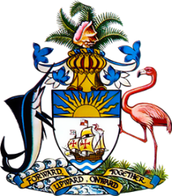

Statement by HE Keva L Bain
Ambassador/Permanent Representative
Permanent Mission of The Bahamas to the United Nations Office and Other International Organizations in Geneva
at the 38th Session of the Universal Periodic Review Working Group
Presentation of National Report by the Government of Namibia
Monday 3 May 2021

Thank you, Madam President.
The Bahamas extends a warm welcome to the delegation of Namibia and thanks the country for its report. It is particularly noteworthy that Namibia recently ratified the Optional Protocol to the Convention on the Rights of the Child, and the Convention Against Torture and other Cruel, Inhuman or Degrading Treatment or Punishment.
The Bahamas submits the following recommendations to Namibia:

- Enact legislation specifically prohibiting discrimination based on age and disability status, and legislation aimed at reducing de facto discrimination in all forms

- Enact legislation to improve women and girls’ rights, by protecting them from gender based violence, increasing their access to health care, and increasing their representation in government and political life.

We wish the delegation of Namibia every success in this UPR process.

I thank you.

