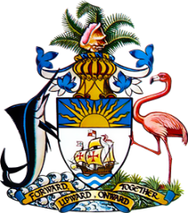

Statement by Mr Frank Davis
Permanent Mission of The Bahamas to the United Nations Office and Other International Organizations in Geneva
at the 38th Session of the Universal Periodic Review Working Group
Presentation of National Report by the Government of Solomon Islands
10th May 2021

Thank you, Madam President.
The Bahamas extends a warm welcome to the delegation of the Solomon Islands and thanks the country for its report.
The Bahamas submits the following recommendations to the Solomon Islands:

- ratify the Convention on the Rights of Persons with Disabilities;
- ratify the International Covenant on Civil and Political Rights;
- ratify the Convention against Torture and Other Cruel, Inhuman or Degrading Treatment or Punishment;
- take additional steps to address the sexual exploitation of children, particularly within logging camps;
- continue its efforts to reform the Penal Code; and
- continue its efforts to implement legislation to make education compulsory for early childhood, primary and secondary education.

We congratulate the Solomon Islands for submitting its first Voluntary National Review on the status and progress of implementation of its 2030 Sustainable Development Goals in 2020.
We also acknowledge the adoption of a Public Service Transformation Strategy to sensitize gender in governance and gender equality.

We wish the delegation every success in this UPR process.

I thank you.

