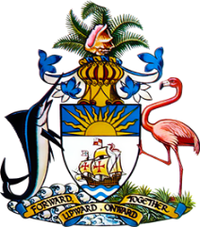

Statement by Ms Kristie Russell
Permanent Mission of The Bahamas to the United Nations Office and Other International Organizations in Geneva
at the 38th Session of the Universal Periodic Review Working Group
Presentation of National Report by the Government of Singapore
12 May 2021

Thank you, Madam President.
The Bahamas extends a warm welcome to the delegation of Singapore and we appreciate Singapore’s detailed national report and commend efforts undertaken thus far.

We congratulate Singapore’s efforts to increase women’s participation in politics and public service, and strides taken to build an inclusive and socially cohesive society that supports the elderly and persons with disabilities.

The Bahamas recommends that Singapore:

- Review the Protection from Online Falsehoods and Manipulation Act (POFMA);

and,

- Encourage the implementation of environmental legislation to combat climate change and its negative impacts on human rights.

We wish Singapore a successful UPR process.

I thank you.
(45 seconds = 113 words)

