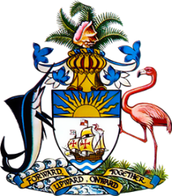

Statement by Mr Frank Davis
Permanent Mission of The Bahamas to the United Nations Office and Other International Organizations in Geneva
at the 38th Session of the Universal Periodic Review Working Group
Presentation of National Report by the Government of Seychelles
10 May 2021

Thank you, Madam Vice President.
The Bahamas welcomes the delegation of Seychelles and is appreciative of its detailed national report which underlined efforts initiated and implemented during the review period.
We congratulate Seychelles on its efforts to combat corruption, money laundering, terrorism financing, domestic violence, trafficking in persons and the protection of victims.
As a fellow Small Island Developing State, The Bahamas stands in solidarity with its efforts that support environmental protection and climate action.

In a constructive spirit, The Bahamas recommends that Seychelles:

- Continue to strengthen its reporting commitments to international treaties and international human rights mechanisms;

- Ratify the Conventions on the Rights of the Child (CRC) and the Rights of Persons with Disabilities;

and,

- Ratify the Convention against Torture and other Cruel, Inhuman or Degrading Treatment or Punishment.

We encourage Seychelles to avail itself of technical assistance and capacity-building support, in accordance with its development priorities and call on the cooperation of the international community in this regard. We wish Seychelles every success in this UPR process.

I thank you.

(Speaking time allocated: 1 minute and 20 seconds)

