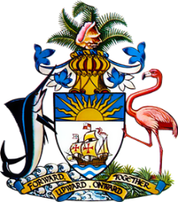

Statement by Her Excellency Keva Bain, Ambassador/Permanent Representative
Permanent Mission of The Bahamas to the United Nations Office and Other International Organizations in Geneva
at the 38th Session of the Universal Periodic Review Working Group
Presentation on the National Report by the Government of Paraguay
Wednesday 5th May 2021

Thank you, Madam, [Vice] President.

The Bahamas extends a warm welcome to the delegation of Paraguay, and thanks the country for its national report and its commitment to this UPR Process.

We commend Paraguay on the progress made to its legal framework to protect the environment through the adoption of the Paris Agreement and to protect human life through establishing a Comprehensive Act to Combat Trafficking in Persons.
The Bahamas submits the following recommendations to Paraguay:

- Ratify the Optional Protocol to the International Covenant on Economic, Social and Cultural Rights

- Take concrete steps to close the pay gap between men and women, as well as the underrepresentation of women in public life

- Address the ongoing violations of the land rights of indigenous communities.
We wish the delegation of Paraguay every success during the UPR process.

I thank you.

