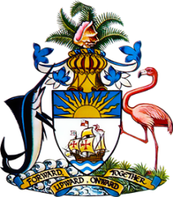

Statement by HE Keva L Bain
Ambassador/Permanent Representative
Permanent Mission of The Bahamas to the United Nations Office and Other International Organizations in Geneva
at the 38th Session of the Universal Periodic Review Working Group
Presentation of National Report by the Government of Denmark
6th May 2021

Thank you, Madam President.
The Bahamas warmly welcomes the delegation of Denmark and thanks Denmark for its report.
The Bahamas submits the following recommendations to Denmark:

- take measures to combat increasing levels of child poverty, particularly among children with ethnic backgrounds; and
- take measures to increase prosecution of perpetrators of sexual violence.

We commend Denmark’s commitment to achieve equal opportunities, equal rights, and non-discrimination for all citizens and for taking steps to improve the position of persons with disabilities by amending the Prohibition Against Discrimination on Grounds of Disability Act, and its aim to put 13,000 more people with disabilities in employment by 2025.

We encourage Denmark to continue to strengthen its counter-terrorism measures and wish the delegation a successful UPR process.

Thank you.

