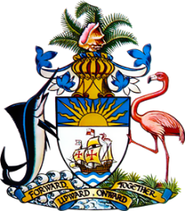

Statement by HE Keva L Bain
Ambassador/Permanent Representative
Permanent Mission of The Bahamas to the United Nations Office and Other International Organizations in Geneva
at the 38th Session of the Universal Periodic Review Working Group
Presentation of National Report by the Government of Belgium
Wednesday, 5 May 2021

Thank you, Madam President,
The Bahamas extends a warm welcome to the delegation of Belgium and thanks the country for its report. It is noteworthy that Belgium has taken efforts to decrease the gender pay gap, decrease the under representation of women in government and managerial posts, while also increasing legal protections for its citizens by expanding the right to access to counsel and improving conditions in overcrowded prisons.

The Bahamas submits the following recommendations to Belgium:

- Take steps to reduce rates of child poverty and discrimination against children, particularly those of migrant backgrounds

- Take steps to improve the situation of persons experiencing homelessness

We wish the delegation of Belgium every success in this UPR process.

I thank you.

