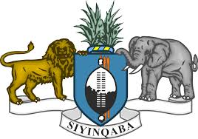

STATEMENT OF THE KINGDOM OF ESWATINI ON THE UPR PROCESS OF THE REPUBLIC OF SOMALIA
Eswatini warmly welcomes the delegation of Somalia, and we welcome the progress made in developing its legislation on the Rights of People living with disabilities.

In the spirit of constructive dialogue, we recommend Somalia to:
- Ratify the Convention on the Elimination of All Forms of Discrimination against Women
- Ratify the African Charter on Human and Peoples’ Rights on the Rights of Women in Africa
- Accede to the Convention relating to the Status of Stateless Persons and
- Strengthening its laws on enabling women and girls to have access to education, health and social welfare.

Eswatini wishes Somalia success in her 3rd cycle of the UPR Review.

I thank you.

