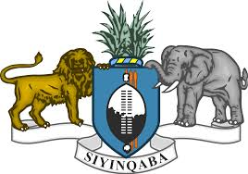

STATEMENT OF THE KINGDOM OF ESWATINI ON THE UPR PROCESS OF THE REPUBLIC OF SIERRA LEONE
The Kingdom of Eswatini warmly welcomes the delegation of Sierra Leone, and notes the progress made by Sierra leone in her implementing recommendations during the second cycle of the UPR.

In the spirit of constructive dialogue, we recommend Sierra leone to:
- Continue Improving the rights of women and girls- by prohibiting FGM.
- Continue promoting its health and social benefits system.
- Eliminate discrimination against children in the most vulnerable situations, such as girls, children with disabilities, children living with HIV/AIDS, children orphaned as a result of Ebola and children in rural areas

Eswatini wishes Sierra leone success in her 3rd cycle of the UPR Review.
I thank you.

