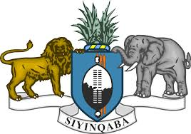

STATEMENT OF THE KINGDOM OF ESWATINI ON THE UPR PROCESS OF THE REPUBLIC OF MOZAMBIQUE
The Kingdom of Eswatini warmly welcomes the delegation of Mozambique, and notes the progress made by Mozambique in her implementing recommendations during the second cycle of the UPR.
Madam President,
In the spirit of constructive dialogue, we recommend Mozambique to continue:
- Strengthening its laws on statelessness, human trafficking and people smuggling
- Improving the rights of women and girls-ensuring access to social benefits, health and education.
- Ensuring that citizens all have access to health especially the elderly, people living with albinism and people living with disabilities.

Eswatini wishes Mozambique success in her 3rd cycle of the UPR Review.
I thank you.

