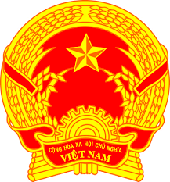
Statement of the Socialist Republic of Viet Nam
At the 38th Session of the UPR Working Group
Review of Singapore
(Geneva, 12 May 2021, 9:00-12:30)

Delivered by
H.E. Ambassador LE Thi Tuyet Mai, Permanent Representative of Viet Na​​m
to the United Nations, the World Trade Organization and
o​ther International Organizations in Geneva

Madam President,
Viet Nam commends Singapore for its strong record on human rights and commitment to the rule of law and building an inclusive, cohesive and resilient society.
In a constructive spirit, Viet Nam recommends the following to Singapore:
- Enhance measures to ensure the protection of the rights and well-being of older persons, including efforts to reduce ageism.
- Continue efforts to ensure an inclusive, cohesive and resilient society, especially within the context of the COVID-19 response.
In closing, Viet Nam wishes Singapore a successful UPR review.
I thank you, Madam President./.

