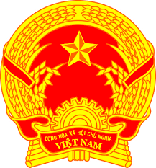
Statement of the Socialist Republic of Viet Nam
At the 38th Session of the UPR Working Group
Review of Seychelles
(Geneva, 10 May 2021, 14:30 – 18:00)
Delivered by
Ms. NGUYEN Phuong Anh, Deputy Permanent Representative of Viet Na​​m to the United Nations, the World Trade Organization and o​ther International Organizations in Geneva, Switzerland

Madam President,
Viet Nam is pleased to welcome and thank the delegation of Seychelles for the comprehensive presentation of the national UPR report.
Viet Nam welcomes the efforts of Seychelles in the implementation of the recommendations accepted under the 2nd UPR cycle. Viet Nam takes a good note of the measures put in place to better promote and protect rights of women, children and persons with disabilities.
In a spirit of constructive dialogue, Viet Nam would like to recommend Seychelles to continue its efforts to strengthen legislative, policy and institutional measures in order to prevent, combat and punish human trafficking.
Viet Nam wishes Seychelles a successful review.
Thank you, Madam President./.

