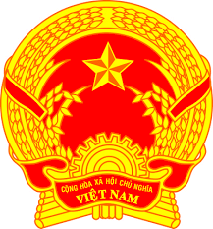
Statement of the Socialist Republic of Viet Nam
Delivered by H.E. Dr. LE Thi Tuyet Mai,
Ambassador Extraordinary and Plenipotentiary
Permanent Representative of Viet Nam to the United Nations Office in Geneva
At the 38th Session of the UPR Working Group
Review of Mozambique
(Geneva, 04 May 2021)

Madam President,
Viet Nam thanks the delegation of Mozambique for the comprehensive presentation of the national UPR report.
Viet Nam welcomes Mozambique’s commitments, efforts and progress in promoting and protecting human rights. In particular, we commend Mozambique’s approval of legislation and policies to combat gender inequalities in various areas of life and early marriages, and its work to improve women’s political participation in central and local decision-making level.
In a spirit of constructive dialogue, Viet Nam would like to make the following recommendations to Mozambique:
1. Adopt and implement the National Human Rights Policy and Strategy as planned.
2. Improve the legal and institutional framework to promote and protect the rights of persons with disabilities and persons with albinism.
Viet Nam wishes Mozambique a successful review.
Thank you, Madam President./.

