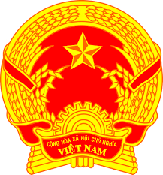
Statement of the Socialist Republic of Viet Nam
At the 38th Session of the UPR Working Group
Review of Latvia
(Geneva, 11 May 2021)

Madam President,
Viet Nam thanks the delegation of Latvia for the comprehensive presentation of the national UPR report.
Viet Nam welcomes the efforts of Latvia in the implementation of the recommendations accepted under the 2nd UPR cycle. Viet Nam takes good note of the efforts of Latvia to combat human trafficking and facilitate the naturalization procedure for children of non-citizens born in Latvia.
In a spirit of constructive dialogue, Viet Nam would like to make the following recommendations to Latvia:
1. Continue to improve the legal framework and implement practical measures to prevent violence against women.
2. Continue its efforts to promote and protect the rights of persons with disabilities.
Viet Nam wishes Latvia a successful review.
Thank you, Madam President./.

