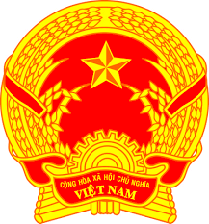
Statement of the Socialist Republic of Viet Nam
At the 38th Session of the UPR Working Group
Review of the Kingdom of Denmark
(Geneva, 06 May 2021, 9:00-12:30)

Delivered by
Ms. NGUYEN Phuong Anh, Deputy Permanent Representative of Viet Na​​m to the United Nations, the World Trade Organization and o​ther International Organizations in Geneva, Switzerland

Madam President,
Viet Nam welcomes the delegation of the Kingdom of Denmark and thanks it for the presentation today.
We commend the commitment of Denmark to the promotion and protection of human rights and its constructive engagement with the UPR mechanism and the Human Rights Council, especially during the Danish membership of the HRC in 2019-2021.
In a constructive spirit, Viet Nam recommends that Denmark:
- Strengthen the integration process for minority groups and non-citizens so that they can enjoy equal access to, inter alia, employment, education, housing, health services and justice.
- Streamline initiatives aimed at preventing hate speech and fighting intolerance in a comprehensive effort to prevent extremism and radicalization.
Finally, we wish Denmark every success in this UPR cycle.
I thank you, Madam President./.

