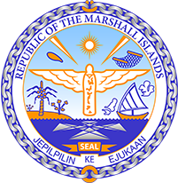

Republic of the Marshall Islands
STATEMENT by H.E. Doreen de Brum, Ambassador & Permanent Representative
38th Session, Universal Periodic Review
7 May 2021
Geneva

Interactive Dialogue: Palau

Check against delivery

Thank you, Madam President,

The Republic of the Marshall Islands warmly welcomes the delegation of Palau and thanks them for their report.

We commend Palau on its ongoing initiatives to improve the child protection system, as well as programs designed to support children and families, through mechanisms strengthening family engagement.

Likewise, we welcome Palau’s efforts to enhance its climate change adaptation and resilience, most notably through its Climate Change Policy for Climate and Disaster Resilient Low Emissions Development. We further note with satisfaction the measures taken to mainstream this policy, as well as the development of other projects designed to mitigate the effects of climate change.

We offer the following recommendations for Palau’s consideration:
- Continue efforts towards the ratification of the Convention Against Torture.
- Improve its ability to manage unexpected disasters and minimize disaster risks.
In closing, we wish the delegation of Palau every success during this third UPR cycle.

Kommol tata and I thank you.

