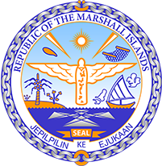

Republic of the Marshall Islands
STATEMENT by Mr Samuel K Lanwi Jr. Deputy Permanent Representative
38th Session, Universal Periodic Review
10 May 2021
Geneva

Interactive Dialogue: Seychelles

Check against delivery

Speaking time: 1 minute and 20 seconds

Thank you, Madam President,

The Republic of the Marshall Islands warmly welcomes the delegation of Seychelles and thanks them for their report.

We welcome Seychelles’ adoption of new policies with regards to child rights, especially those prohibiting all forms of corporal punishment of children.

Likewise, we are pleased to note its initiatives to fight discrimination against disabled persons, most notably through the establishment of a national strategic framework for disability.

Lastly, we commend Seychelles for its adoption of regulations on the protection of the environment and for its efforts to mitigate the effects of climate change.

We offer the following recommendations for Seychelles’ consideration:
- Operationalise the Domestic Violence Act and establish a mechanism to offer increased support to victims of domestic violence
- Fully implement the measures taken to ensure the involvement of disabled persons in society, including children
- Ensure that children are not used in the traffic of illegal substances

In closing, we wish the delegation of Seychelles every success during this third UPR cycle.

Kommol tata and I thank you.

