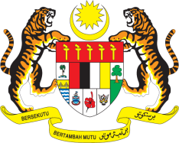

Statement by Malaysia
Review of Niger
38th Session of the UPR Working Group
3 - 14 May 2021

Malaysia thanks Niger for the presentation of its national report.

- Malaysia welcomes Niger’s engagement in the Human Rights Council’s UPR mechanism and efforts made since its second UPR on the human rights front. Malaysia looks forward for further progress that would effectively benefit the people of Niger and improve their human rights, wellbeing and livelihood. On this note, Malaysia is pleased with Niger’s national action plan for youth employment, which is currently being developed. We hope that young people have been included in the process and look forward to its effective and inclusive implementation.

- In the spirit of constructive engagement, Malaysia recommends the following:

  - allocate sufficient resources for the National Human Rights Commission to enable it to discharge its mandate in full, in accordance with the Paris Principles;
  - strengthen efforts to ensure right to health for all including through adequate health facilities, personnel and services;
  - develop a national plan of action in line with international standards to combat slavery which include effective measures to free victims of traditional slavery practices and provide children with rehabilitation, psychological recovery services and assistance for reintegrating into their families; and
  - continue taking steps to address gender-based violence including through stringent punishments for perpetrators.

Malaysia wishes Niger a successful review.

Thank you.

GENEVA
3 May 2021

