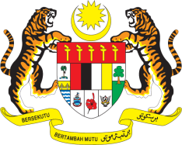

Statement by Malaysia
Review of Somalia
38th Session of the UPR Working Group
3 - 14 May 2021

Malaysia thanks Somalia for the presentation of its national report.

- Malaysia welcomes Somalia’s engagement with the Human Rights Council’s mechanisms, including the UPR. We are pleased to note that Somalia has taken efforts to implement recommendations from its second UPR including those made by Malaysia. In this connection, we laud Somalia for ratifying the CRPD and hope that the Government would expedite necessary process towards the ratification of CEDAW. We also urge the Government to ensure the operationalisation of a National Human Rights Institution that is in line with the Paris Principles.

- In this spirit of constructive engagement, Malaysia recommends the following:

  - realise the right to education for all by ensuring an enhanced, coherent and comprehensive nationwide education system;
  - provide victims, including of sexual and gender-based violence, with holistic support and assistance, including medical and social support, and access to remedies and full reparations;
  - ensure access to health care for all; and
  - make concrete efforts to protect and promote the rights of women and girls and eliminate gender - based discrimination

- We wish Somalia a successful review.

Thank you.

GENEVA
6 May 2021

