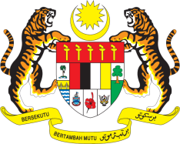

Statement by Malaysia
Review of Solomon Islands
38th Session of the UPR Working Group
3 - 14 May 2021

Malaysia welcomes the delegation of Solomon Islands to the Human Rights Council’s Universal Periodic Review.

- Malaysia has taken note of the reports on Solomon Islands that have been submitted within the framework of the 38th Session of UPR Working Group. We encourage Solomon Islands to continue its engagement with the Human Rights Council’s mechanism particularly the UPR and take targeted and inclusive measures to implement accepted recommendations. We hope that the Government would avail itself to the technical cooperation and capacity building to further advance human rights of its people.

- In the spirit of constructive engagement, Malaysia recommends the following:

  - continue taking steps to improve access to education for all by addressing barriers and provide sufficient budget for the education sector;
  - ensure the provision of and access to age-appropriate information, education and adolescent-friendly comprehensive, quality and timely sexual and reproductive health services at both government and non-government led health facilities for adolescents and youth, including those with disabilities; and
  - expedite and take concrete steps to establish a national human rights institution that is in compliance with the Paris Principles

- Malaysia wishes Solomon Islands a successful review.

Thank you.

GENEVA
10 May 2021

