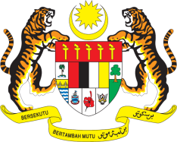

Statement by His Excellency Dato’ Dr. Ahmad Faisal Muhamad
Review of Singapore
38th Session of the UPR Working Group
3 - 14 May 2021

Malaysia thanks Singapore for the presentation of its national report.

- Malaysia commends Singapore’s commitment to the UPR, and notes the progress made in implementing recommendations from its previous reviews.

- In the spirit of constructive engagement, Malaysia offers three recommendations:

  - continue efforts to protect children and youth against sexual exploitation;
  - intensify measures to enhance the enjoyment of freedom of religion or belief, including by lifting the ban on the wearing of hijab by Muslim women employees in the public services; and
  - take steps to establish a National Human Rights Institution, in compliance with the Paris Principles.

- Malaysia wishes Singapore a successful review.

GENEVA
12 May 2021

