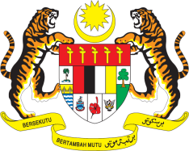

Statement by Malaysia
Review of Sierra Leone
38th Session of the UPR Working Group
3 - 14 May 2021

Malaysia thanks Sierra Leone for the presentation of its national report.

- Malaysia welcomes the progress made by Sierra Leone since its second UPR. We further welcome the collaborative and inclusive approach by the Government in pursuing its UPR commitments.

- We are pleased to note Sierra Leone’s successful transition from a Peacebuilding Commission agenda-country to an aspiring middle-income country by 2035. We hope further progress will be pursued, and in the spirit of constructive engagement, Malaysia recommends the following:

  - Continue taking steps to realise the right to education and gender equality in education;
  - Continue taking steps to address adequately sexual and gender-based violence;
  - Continue taking steps to ensure right to health for all by allocating necessary resources; and
  - Strengthen efforts to eliminate discrimination against children in vulnerable situations, among others children with disabilities and children living with HIV/AIDS.

- Malaysia wishes Sierra Leone a successful review.

Thank you.

GENEVA
12 May 2021

