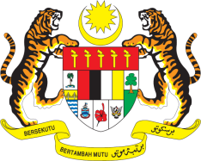

Statement by Malaysia
Review of Seychelles
38th Session of the UPR Working Group
3 - 14 May 2021

Malaysia welcomes the delegation of Seychelles to the Human Rights Council’s Universal Periodic Review.

- Malaysia commends Seychelles for its efforts to advance human rights, social well-being and welfare of its people. We are encouraged with Seychelles’ inclusive approach that paved the way for the enactment of the Domestic Violence Act. Malaysia welcomes Seychelles’ national gender plan of action and the appointment of the National Gender Management Team. We look forward for the effective implementation of these mechanisms.

- Malaysia also lauds the Government for providing necessary support to employees who have been affected during the COVID19 pandemic through the ‘Seychelles Employee Transition’ and ‘Financial Assistance for Job Retention’ schemes. Malaysia further welcomes the adoption of amendments to the Social Security Act that guarantees the welfare of persons with disabilities. We hope the Government would continue taking further steps to promote and protect the rights of specific groups such as children, women, older persons and those with disabilities.

- In the spirit of constructive engagement, Malaysia recommends the following:

  - continue taking concrete measures to address gender-based violence and allocate adequate resources to provide necessary support and reparation for victims; and
  - continue providing sexual and reproductive health services.

- Malaysia wishes Seychelles a successful review.

Thank you.

GENEVA
10 May 2021

