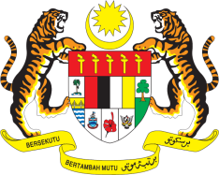

Statement by Malaysia
Review of Palau
38th Session of the UPR Working Group
3 - 14 May 2021

Malaysia thanks Palau for the presentation of its national report.

- Malaysia welcomes the pronouncements made by Palau to the UPR and its commitment to ensure human rights for its people. We further welcome the pledges made to continue promoting gender equality and support for children, elderly, disabled persons, and the vulnerable population. We hope Palau will continue to take steps to mitigate climate change and tackle human trafficking.

- Malaysia made several recommendations during Palau’s second UPR and we wish to acknowledge efforts made in implementing them. Cognizant of the challenges faced by Palau in furthering these efforts, we hope Palau would benefit from the technical cooperation and capacity building that are available including within the framework of the Human Rights Council and the UPR.

- In the spirit of constructive engagement, Malaysia recommends the following:

  - continue taking steps towards establishing a national human rights institution, in accordance with the Paris Principles;
  - adopt and enforce legislation to specifically criminalize the sexual exploitation of children;
  - continue taking steps necessary towards the ratification of the Convention on the Elimination of All Forms of Discrimination Against Women (CEDAW); and
  - promote inclusive education for children with disabilities.

- Malaysia wishes Palau a successful review.

Thank you.

GENEVA
7 May 2021

