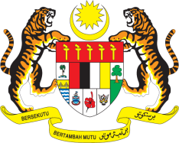

Statement by Malaysia
Review of Namibia
38th Session of the UPR Working Group
3 - 14 May 2021

Malaysia thanks Namibia for the presentation of its national report.

- Malaysia commends Namibia’s commitment to improve human rights in the country. We welcome the various legislative and policy frameworks that have been established and implemented in this regard.

- We note the efforts by the Government to promote gender equality and women empowerment, improve the wellbeing of persons living with disabilities and ensure access to clean water and sanitation - key issues that Malaysia had addressed during Namibia’s second UPR. Malaysia is also pleased to note the increased number of girls and young women graduating from secondary and tertiary institutions, particularly in Science Technology, Engineering and Mathematics (STEM). We hope to see further progress and as such, in the spirit of constructive engagement recommend the following:

  - promptly and adequately address poverty, especially in rural areas and among children through more targeted measures;
  - continue taking effective measures in rural areas to reduce the distance to water points and access to sanitation;
  - take necessary measures to promote employment of persons with disabilities; and
  - raise public awareness on sexual and reproductive health and take efforts particularly to ensure access to information, education and services.

Malaysia wishes Namibia a successful review.

Thank you.

GENEVA
3 May 2021

