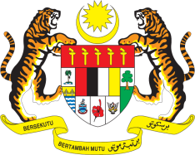

Statement by Malaysia
Review of Mozambique
38th Session of the UPR Working Group
3 - 14 May 2021

Malaysia thanks Mozambique for the presentation of its national report.

- Malaysia acknowledges Mozambique’s efforts to implement the recommendations accepted during its second UPR and advance human rights of its people despite facing numerous challenges. We note the efforts to tackle slavery and trafficking in persons. We encourage the Government to take further steps to tackle such incidences involving people living with albinism. We welcome advancements in the prison system and improvement of conditions in detentions.

- In the spirit of constructive engagement, Malaysia recommends the following:

  - take further measures to improve human rights of persons with albinism and address the widespread discrimination against them;
  - intensify efforts to address poverty and the lack of access to clean water and sanitation among children in rural areas; and
  - ensure provision of GBV prevention and services as essential and life-saving component of the COVID-19 response, and that services remain open and accessible, including provision of hotlines, referrals, case management and psychosocial support for survivors.

- Malaysia wishes Mozambique a successful review.

Thank you.

GENEVA
4 May 2021

