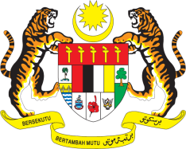

Statement by Malaysia
Review of Latvia
38th Session of the UPR Working Group
3 - 14 May 2021

Malaysia thanks Latvia for the presentation of its national report.

- Malaysia commends Latvia for taking concrete measures in implementing recommendations from its second UPR. We are encouraged to note that Latvia is working towards improving its legal framework, and implement practical measures to prevent violence against women. We also welcome wide-spread awareness raising campaigns by the Government to tackle this issue. In the same vein, we appreciate Latvia’s efforts to address the issue of trafficking in persons. We look forward to further measures that would improve procedures for the early identification and referral to appropriate services for victims.

- In the spirit of constructive engagement, Malaysia recommends the following:

  - continue taking steps to realise right to health among others by ensuring access for services for all including persons with disabilities;

  - strengthen measures to address hate crime and speeches particularly against ethnic and religious minorities; and

  - continue taking steps towards poverty reduction particularly among women and children.

- Malaysia wishes Latvia a successful review.

Thank you.

GENEVA
11 May 2021

