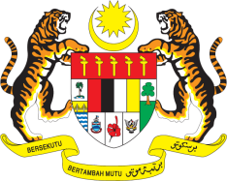

Statement by Malaysia
Review of Estonia
38th Session of the UPR Working Group
3 - 14 May 2021

Malaysia thanks Estonia for the presentation of its national report.

- Malaysia acknowledges the various steps already taken by Estonia to implement recommendations from its second UPR. We are particularly pleased with the establishment of a National Human Rights Institution. While commending steps taken to address incitement to hatred, violence and discrimination particularly against the minorities, Malaysia hopes for stronger, robust and more targeted measures that could address these issues more effectively. We also look forward to the effective implementation of the Population and Coherent Society Development Plan 2021–2030.

- In this spirit of constructive engagement, Malaysia recommends the following:

  - ensure comprehensive protection against hate speech and hate crimes and enforce deterrence through stricter punishment; and
  - ensure children belonging to linguistic and ethnic minorities and children with disabilities are provided with adequate access to education.

- We wish Estonia a successful review.

Thank you.

GENEVA
4 May 2021

