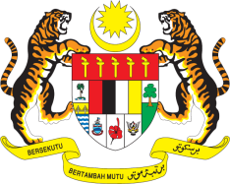

Statement by Malaysia
Review of Denmark
38th Session of the UPR Working Group
3 - 14 May 2021

Malaysia thanks Denmark for the presentation of its national report.

- Malaysia notes progress made by Denmark in the promotion and protection of human rights since its second UPR.

- Malaysia further notes steps taken to address issues related to discrimination, racism, hate crimes, which were all addressed by Malaysia during the last review. We hope the Government would continue taking steps to address these issues adequately and comprehensively. In the spirit of constructive engagement, Malaysia recommends the following:

  - enhance laws and legislation to curb all forms of discrimination, racism and hatred;
  - combat racism and hate speech, especially against religious minorities, immigrants and asylum seekers; and
  - reduce inequalities and take concrete actions to promote inter-racial and inter-religious relations.

- Malaysia wishes Denmark a successful review.

Thank you.

GENEVA
5 May 2021

