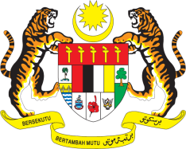

Statement by Malaysia
Review of Belgium
38th Session of the UPR Working Group
3 - 14 May 2021

Malaysia thanks Belgium for the presentation of its national report.

- Malaysia welcomes Belgium’s commitment to the UPR. We note various efforts taken to implement recommendations accepted by Belgium since its second UPR including through legislative and policies reforms.

- In this spirit of constructive engagement, Malaysia recommends the following:

  - expedite the development of an interfederal plan to combat racism and ensure its effective implementation in close consultation with civil society and other relevant stakeholders;
  - take effective measures to eliminate discrimination on the basis of race, ethnicity and religion;
  - guarantee freedom of religion or belief by allowing peaceful expression of religious beliefs, including the wearing of religious symbols;
  - ensure adequate training of authorities involved in the fight against gender-based violence and stricter punishment for perpetrators; and
  - actively and regularly cooperate with civil society for following-up the recommendations from the Universal Periodic Review (UPR) and for drafting the national reports.

- We wish Belgium a successful review.

Thank you.

GENEVA
5 May 2021

