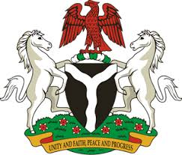
Please check against delivery
HUMAN RIGHTS COUNCIL
38TH SESSION OF THE WORKING GROUP OF THE UPR
REVIEW OF NIGER
3RD MAY, 2021
STATEMENT BY NIGERIA
Madam Vice President,
Nigeria warmly welcomes the delegation of the Republic of Niger, and thanks it for the presentation of the country’s National Report for the Third Cycle UPR, as well as the update provided today. We commend the Government of Niger for its efforts in implementing previous recommendations, and its continued commitment to the UPR mechanism.
2. Nigeria takes positive note of the Government’s efforts at strengthening the country’s legal and institutional frameworks for the promotion and protection of human rights. We also commend the Government for its efforts in combating terrorism, human trafficking and other transnational organised crimes, as well as measures being adopted to enhance the socio-economic wellbeing of its population.
3. While acknowledging efforts by Niger in upholding human rights, and in the spirit of constructive engagement, Nigeria recommends the following to Niger:
- Strengthen measures for the fight against terrorism, human trafficking and other transnational organised crimes;
- Adopt further measures to improve the socio-economic wellbeing of the people, and ensure the protection of the rights of persons in vulnerable situations;
- Scale up efforts in upholding human rights and seek necessary support in this regard.
4. To conclude, we wish Niger every success in its review process.
I thank you.
******

