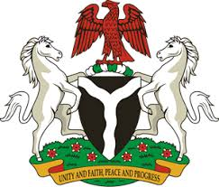
Please check against delivery
HUMAN RIGHTS COUNCIL
38TH SESSION OF THE WORKING GROUP OF THE UPR
REVIEW OF SOMALIA
6TH MAY, 2021
STATEMENT BY NIGERIA
Mr. Vice President,
Nigeria warmly welcomes the delegation of the Federal Republic of Somalia to the presentation of the country’s Third Cycle UPR National Report. We commend the Government of Somalia for its commitment to the UPR process, and its efforts in the implementation recommendations it accepted during the previous review.
2. Nigeria notes with commendation, the Government’s efforts in strengthening the country’s legal and institutional frameworks for the promotion and protection of human rights. We also take positive note of the adoption of the National Reconciliation Framework, and the effort in combatting terrorism, with a view to ensuring sustainable peace and security.
3. In the spirit of constructive dialogue, Nigeria recommends the following to Somalia:
- Scale up efforts at national reconciliation, the fight against terrorism, poverty reduction, and the protection of the rights of persons in vulnerable situations; and
- Continue to mobilise resources and seek necessary support to enhance its capacity to protect and promote human rights.
4. To conclude, we wish Somalia a very successful review process.
I thank you.
******

